**Unit 3 Project  
Setup**  
**Before configuring the NetLab environment, be sure to follow and complete the instructions in this setup. Failure to do so will impact the lab environment - and your lab assignment scores - in later units.  
  
Creating Group Data Folders**

1. Log in to the Bayside Memorial domain using the Administrator account and password.  
     
   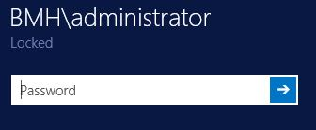
2. Using File Explorer, navigate to the root of the C:\ drive.

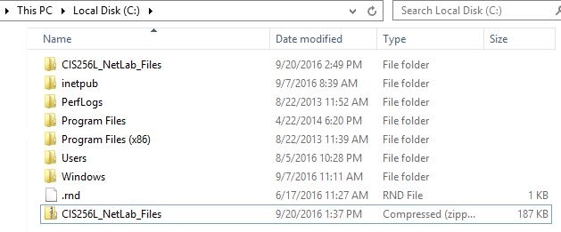

3. Add a folder called **Data**.

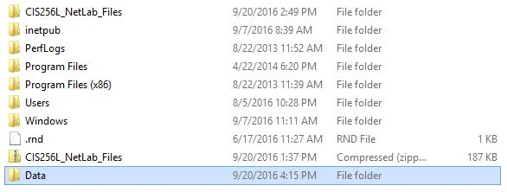

1. Open the Data folder and add folders using the group names you created in your Unit 3 Project Planning. For example – if you use Finance, Medical and Operations, create sub-folders for each group inside Data.

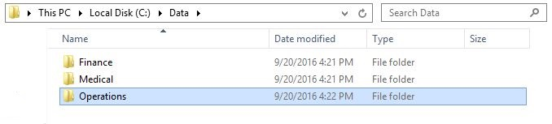

1. Navigate to **C:\CIS256L_NetLab_Files\Group_files**. Copy the entire contents of this sub-folder into **each** of the group sub-folders you created in Step 4.  
     
   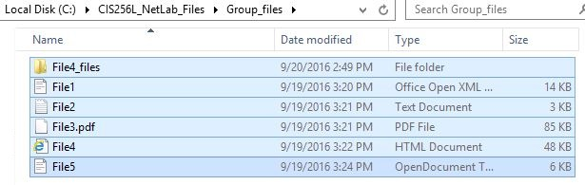
2. Double-check inside each of your group folders to insure they contain files. You will use these to test access to the contents through the permissions/policies you set.
3. Return to the Unit 3 Project Implementation and continue.

**Sharing a folder/device**  
Sharing a folder or devices makes it available for designated users to view or modify it, even remotely. You must determine, however, what permissions are applied at which level in order for this to happen. **NOTE: The steps below demonstrate how to set up a share using the Data folder, but your shared resources, permissions and groups may differ according to your project design.**

1. Log in to the Bayside Memorial domain using the Administrator account and password.  
     
   
2. Using File Explorer, navigate to the root of the C:\ drive and right-click on the Data folder.  
     
   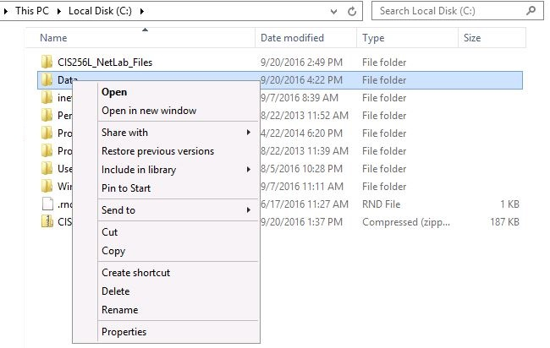

3. Place your cursor on **Share with**, then click **Specific people…**

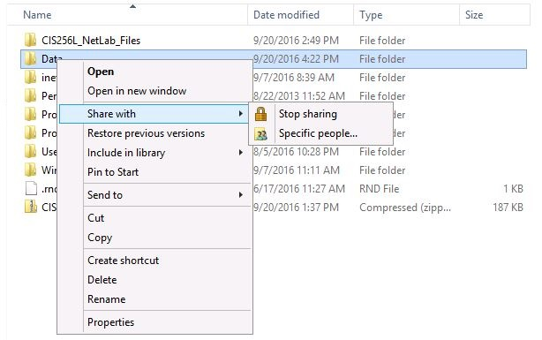

**4.** From here, you can type in an individual user account or group name and click **Add**.

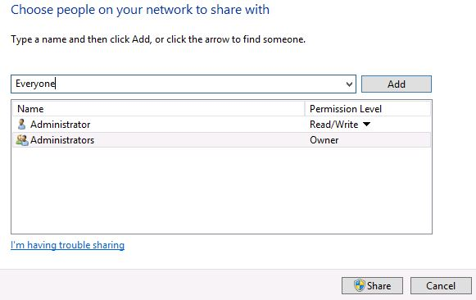

5. Click the arrow under Permission Level to set the user/group permission to this resource. Finally, click **Share** and the resource becomes available to requesting users.

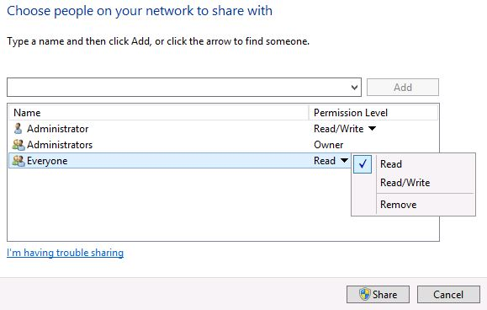

**Mapping a drive**  
Drive mappings create pointers for folders located on remote computing resources. Drive letters are assigned as a convenient way to identify each mapping.

1. Log in to the Bayside Hospital domain from the client machine.

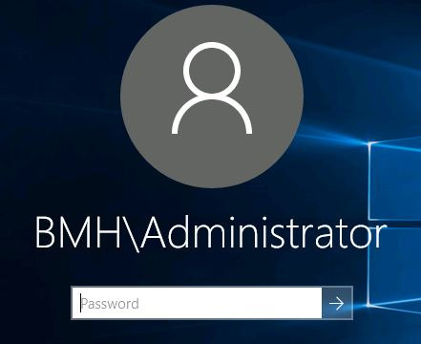

2. Right-click on **File Explorer**, then click **Map network drive**.

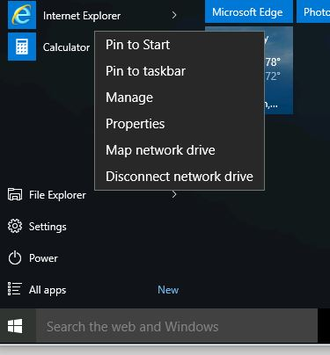

3. Choose a drive letter, then supply the device/share name of the folder you wish to access. Click **Finish**.

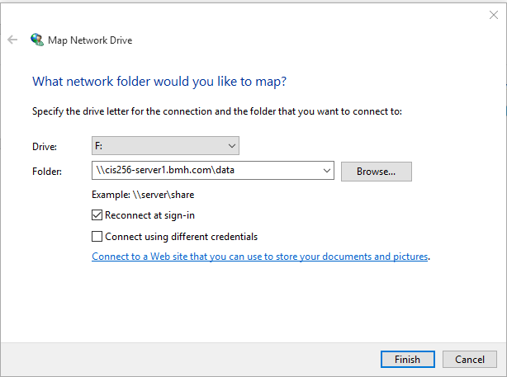

4. Open **File Explorer** – **This PC**. Your mapping should appear as the drive letter you specified.

